MODEL INSTITUTE OF ENGINEERING AND TECHNOLOGY (Autonomous)
Kot Bhalwal, Jammu

SYNOPSIS

MENTAL HEALTH DISORDER CLASSIFICATION

Submitted in partial fulfillment of the requirement for the award of the Degree of
Masters of Computer Applications
SESSION: 2023-2024



SUBMITTED BY
Radhika (2022d1r017)
Sonika Thakur (2022d1r007)
M.CA-1VTH SEM

UNDER THE GUIDANCE OF
Ms. Arti Kotru
(Head M.C.A Department)

TABLE OF CONTENT

- Title Of The Project.............................................................1
- Hardware And Software Requirements...............................2
- Abstract....……....................................................................3
- Introduction..........................................................................4
- Literature survey of MDHC……...........…...........................5
- Working Of MDHC………...................................................6
- Steps Involved For MDHC System.…...................................7
- Methodology……...........…...................................................8
- Flowchart of a ensemble model.…………………………….9
- Conclusion…………….........................................…............10
- References…..………………………………………….…..11

SYNOPSIS

TITLE OF THE PROJECT:

MENTAL HEALTH DISORDER CLASSIFICATION (MHDC)

1
HARDWARE AND SOFTWARE REQUIREMENTS:

- Platform Google colab (GPU support)
- M.L Library Numpy,pandas,scikit-learn, seaborn
- Language Python 3.x
- Hardware computer with internet access

2

ABSRACT:

A mental disorder is characterized by significant disturbances in cognition, emotional regulation, or behavior, often leading to distress or impairment in important areas of functioning. Mental disorders encompass a wide range of conditions and may also be referred to as mental health conditions. The COVID-19 pandemic in 2020 saw a notable increase in anxiety and depressive disorders globally. Anxiety disorders, affecting 301 million people worldwide in 2019, involve excessive fear, worry, and related behavioral disturbances, causing significant distress or impairment. Types include generalized anxiety disorder, panic disorder, social anxiety disorder, and separation anxiety disorder. Effective psychological treatments and, in some cases, medication are available. Depression, affecting millions globally, differs from usual mood fluctuations and poses an increased risk of suicide. Bipolar disorder, experienced by 40 million individuals, involves manic symptoms like euphoria, increased activity, and impulsivity, along with depressive episodes. People with bipolar disorder also face an increased risk of suicide. Despite effective prevention and treatment options, access to care remains limited for many, compounded by stigma, discrimination, and human rights violations. Addressing mental health challenges requires comprehensive strategies that encompass prevention, early intervention, and access to evidence-based treatments, along with efforts to combat stigma and discrimination.

Key Words:- MHDC: Linear Regression(LR),Random forest(RF), SVM (Support Vector Machine), Ensemble model.

3
INTRODUCTION:

A mental disorder is characterized by a clinically significant disturbance in an individual’s cognition, emotional regulation, or behaviour. It is usually associated with distress or impairment in important areas of functioning. There are many different types of mental disorders. Mental disorders may also be referred to as mental health conditions. The latter is a broader term covering mental disorders, psycho-social disabilities and (other) mental states associated with significant distress, impairment in functioning, or risk of self-harm. This fact sheet focuses on mental disorders as described by the International Classification of Diseases 11th Revision (ICD-11). In 2020, the number of people living with anxiety and depressive disorders rose significantly because of the COVID-19 pandemic. Initial estimates show a 26% and 28% increase respectively for anxiety and major depressive disorders in just one year . While effective prevention and treatment options exist, most people with mental disorders do not have access to effective care. Many people also experience stigma, discrimination and violations of human rights.In 2019, 301 million people were living with an anxiety disorder including 58 million children and adolescents. Anxiety disorders are characterized by excessive fear and worry and related behavioral disturbances. Symptoms are severe enough to result in significant distress or significant impairment in functioning. There are several different kinds of anxiety disorders, such as: generalized anxiety disorder (characterized by excessive worry), panic disorder (characterized by panic attacks), social anxiety disorder , separation anxiety disorder (characterized by excessive fear or anxiety about separation from those individuals to whom the person has a deep emotional bond), and others. Effective psychological treatment exists, and depending on the age and severity, medication may also be considered. Depression is different from usual mood fluctuations and short-lived emotional responses to challenges in everyday life. People with depression are at an increased risk of suicide. .In 2019, 40 million people experienced bipolar disorder . Manic symptoms may include euphoria or irritability, increased activity or energy, and other symptoms such as increased talkativeness, racing thoughts, increased self-esteem, decreased need for sleep, destructibility, and impulsive reckless behaviour. People with bipolar disorder are at an increased risk of suicide.
4

Literature survey:

The paper discusses the process of diagnosing mental disorders based on symptoms and signs, the relevance of major diagnostic manuals, and the contrast with the National Institute of Mental Health’s Research Domain Criteria. It also identifies key issues in understanding and classifying mental disorder and discusses how the approaches of the three systems correspond or diverge.[1]The methodology involves acknowledging the uniqueness of each case, identifying common characteristics to categorize cases, and forming general nomothetic conclusions based on these common characteristics.[2]The methodology involves discussing sources of disagreement on psychiatric classification and suggesting principles to address them. The author has previously published related work in collaboration with another researcher.[3]The paper discusses the process of diagnosing mental disorders based on symptoms and signs, the relevance of major diagnostic manuals, and the contrast with the National Institute of Mental Health’s Research Domain Criteria. It also identifies key issues in understanding and classifying mental disorder and discusses how the approaches of the three systems correspond or diverge.[4]The methodology involves addressing specific issues related to the revisions of classifications of mental disorders, suggesting an empirically based structure, accepting the dimensional nature of disorders, defining thresholds for categories, and proposing reduced and enhanced criterion sets for clinical and decision support use.[5]The methodology involves using observed data and precise definitions for classification, addressing the weak validity of the classification strategy, considering sub-threshold conditions, measuring different dimensions independently from a threshold, and emphasizing early identification for future therapeutic strategy and prevention.[6]

5
WORKING OF MHDC:

The overview you provided offers a comprehensive understanding of Linear Regression (LR), Random Forest (RF), Support Vector Machine (SVM), ensemble models, dataset details, and the steps involved in training data, preprocessing, building an ensemble model, training & evaluation, and testing & prediction in machine learning.Linear Regression (LR), Random Forest (RF), and Support Vector Machine (SVM) are powerful supervised machine learning algorithms used for various classification and regression tasks. Ensemble models combine multiple individual models to improve predictive performance and robustness. The dataset contains four types of mental health disorder datasets: normal, depression, bipolar-type 1, and bipolar type 2. It consists of 17 features related to mental health, including Sadness, Euphoric, Exhausted, Sleep Disorder, and others. The dataset comprises 121 samples for analysis. The dataset contains four types of mental health disorder datasets: normal, depression, bipolar-type 1, and bipolar type 2. It consists of 17 features related to mental health, including Sadness, Euphoric, Exhausted, Sleep Disorder, and others. The dataset comprises 121 samples for analysis.
Analyzing the System:- Analyzing the system involves assessing the performance of the machine learning models, identifying any issues or limitations, and making improvements as necessary.This may include analyzing metrics such as accuracy, precision, recall, F1 score, mean squared error, and R-squared to evaluate model performance. Feature importance analysis can be performed to understand the contribution of each feature to the model's predictions. Model interpretation techniques, such as SHAP values or partial dependence plots, can provide insights into how the models make predictions. Each step is crucial in ensuring the effectiveness, reliability, and generalization ability of the models for various tasks and domains. Analyzing the system involves rigorous evaluation and interpretation of the model's performance and behavior to make informed decisions and improvements.

6

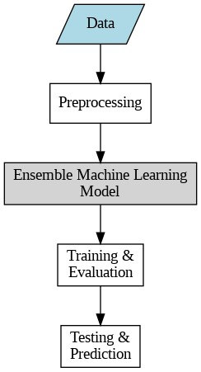

Fig 1: Steps involved in MHDC

7

METHODOLOGY:

Linear Regression(LR):- Linear regression(LR) is also a type of machine-learning algorithm more specifically a supervised machine-learning algorithm that learns from the labelled datasets and maps the data points to the most optimized linear functions. which can be used for prediction on new datasets.
Random forest(RF) : -Random Forest is a classifier that contains a number of decision trees on various subsets of the given dataset and takes the average to improve the predictive accuracy of that dataset. Instead of relying on one decision tree, the random forest takes the prediction from each tree and based on the majority votes of predictions, and it predicts the final output.
Support Vector Machine(SVM):- A support vector machine (SVM) is a supervised machine learning model that uses classification algorithms for two-group classification problems. After giving an SVM model set of labeled training data for each category, they're able to categorize new text.
Ensemble model:- Ensemble means ‘a collection of things’ and in Machine Learning terminology, Ensemble learning refers to the approach of combining multiple ML models to produce a more accurate and robust prediction compared to any individual model. Support Vector Machine (SVM) is a powerful supervised learning algorithm used for classification and regression tasks. Linear regression is a widely used statistical technique for regression analysis. It assumes a linear relationship between the independent variables and the dependent variable. Random Forest is a classifier that contains a number of decision trees on various subsets of the given data set and takes the average to improve the predictive accuracy of that dateset.These algorithms offer diverse approaches to solving machine learning tasks, each with its unique strengths and applications.

8

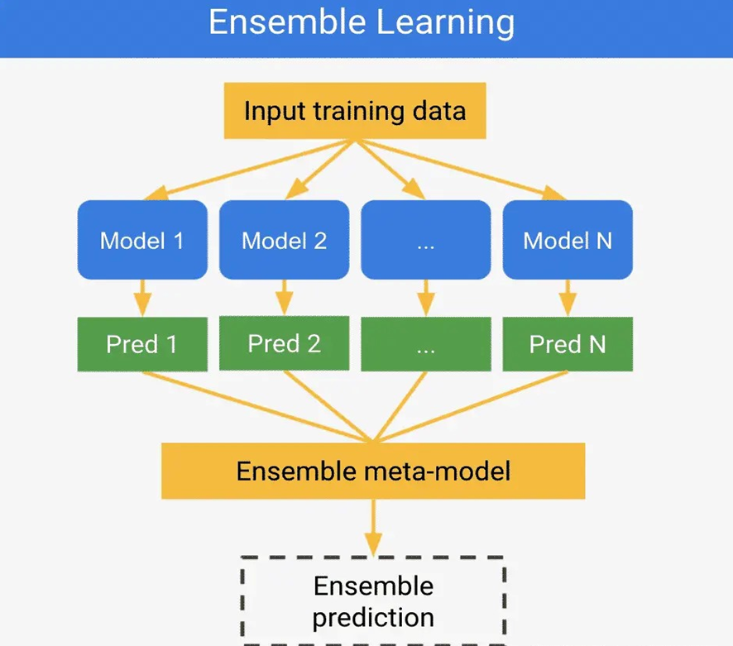

Fig 2: Flowchart of ensemble
(https://www.jcchouinard.com/wp-content/uploads/2021/11/image-10.png)

Details of Dataset:-
In mental health disorder classification, datasets typically contain various features that are used to characterize individuals' mental health status. It has four categories of diseases in the Mental Health Disorder (normal, depression , bipolar-type-1, bi-polartype-2.It provides 17 features in our dateset Sadness,Euphoric,Exhausted, Sleep Disorder,Mood swing, Suicidal thought, Anorxia, Authority Respect,Try-Explanation, Aggressive response, Ignore & Move-On, Nervous break down, Admit Mistakes ,Overthinking ,Sexual Activity, Concentration, Optimism. Our dateset has 121 samples.
Steps involved in training data, preprocessing, building an ensemble model, and training & evaluation, followed by testing & prediction in machine learning:-
- Training Data:- The training data is the dataset used to train the machine learning model. It consists of input features and corresponding target labels or outcomes.Typically, the dataset is split into training and testing sets, with the training set used to train the model and the testing set used to evaluate its performance.
9
- Preprocessing:- Preprocessing involves cleaning, transforming, and preparing the data for modeling. Preprocessing ensures that the data is in a suitable format for the machine learning algorithm and helps improve the performance and stability of the model.
- Ensemble Model:- An ensemble model combines multiple individual models to improve predictive performance and robustness. Common ensemble methods include Random Forest, Gradient Boosting Machines (GBM), AdaBoost, and Stacking.
- Training & Evaluation:- The training phase involves fitting the machine learning model to the training data. During training, the model learns patterns and relationships in the data using optimization techniques such as gradient descent.
- Testing & Prediction:- Once the model is trained and evaluated, it can be used to make predictions on new, unseen data. The testing phase involves applying the trained model to the testing dataset to generate predictions. Predictions are evaluated using the same evaluation metrics used during training and evaluation to assess the model's generalization performance.
Overall, the process of training data, preprocessing, building an ensemble model, and training & evaluation, followed by testing & prediction, forms a structured approach to developing and deploying machine learning models for various tasks and domains. Each step is crucial in ensuring the model's effectiveness, reliability, and generalization ability.

* Mental Disorder Classification (kaggle.com)
10

Conclusion:-
In conclusion, analyzing the system involves rigorous evaluation and interpretation of model performance and behavior to ensure effectiveness, reliability, and generalization ability across various tasks and domains. This process facilitates informed decision-making and continuous improvement of machine learning models.The analysis involves assessing model performance using metrics like accuracy, precision, recall, F1 score, mean squared error, and R-squared. Feature importance analysis helps understand the contribution of each feature to the model's predictions. Model interpretation techniques, such as SHAP values or partial dependence plots, provide insights into prediction mechanisms.Analyzing the system involves rigorous evaluation and interpretation of the model's performance and behavior to make informed decisions and improvements.

11
References:
- Clark, Lee Anna et al. “Three Approaches to Understanding and Classifying Mental Disorder: ICD-11, DSM-5, and the National Institute of Mental Health’s Research Domain Criteria (RDoC).” Psychological Science in the Public Interest 18 (2017): 145 - 72.
- Wolman, Benjamin B.. “Classification and Diagnosis of Mental Disorders.” (1978).
- Essen-Möller, E. “ON CLASSIFICATION OF MENTAL DISORDERS.” Acta Psychiatrica Scandinavica 37 (1961): n. pag.
- Clark, Lee Anna et al. “Three Approaches to Understanding and Classifying Mental Disorder: ICD-11, DSM-5, and the National Institute of Mental Health’s Research Domain Criteria (RDoC).” Psychological Science in the Public Interest 18 (2017): 145 - 72.
- Andrews, Gavin et al. “Classification of Anxiety and Depressive disorders: problems and solutions.” Depression and Anxiety 25 (2008): n. pag.
- Lecrubier, Yves. “Refinement of diagnosis and disease classification in psychiatry.” European Archives of Psychiatry and Clinical Neuroscience 258 (2008): 6-11.

12

